langUAge Paper 2 Sections A (Reading) and B (Writing) Writer’s viewpoints and perspectives | 50 % of Language GCSE  1 hour and 45 minutes  80 marks in total  Sec A Reading 40 marks – 2 linked texts: one non-fiction and one literary non-fiction. 1 short form question worth 4 marks, 2 longer questions worth 8 and 12 marks and an extended question worth 16 marks  The Reading section will act as a stimulus to the Writing section  Sec B Writing to present a viewpoint 40 marks – 1 extended writing question worth 40 marks in total (24 content and organisation, 16 technical accuracy)

Assessment Objectives
Assessment objectives (AOs) are set by Ofqual and are the same across all GCSE English Language specifications and all exam boards. The exams and Spoken Language endorsement will measure how students have achieved the following assessment objectives.
- AO1: identify and interpret explicit and implicit information and ideas; select and synthesise evidence from different texts
- AO2: Explain, comment on and analyse how writers use language and structure to achieve effects and influence readers, using relevant subject terminology to support their views
- AO3: Compare writers’ ideas and perspectives, as well as how these are conveyed, across two or more texts
- AO5: Communicate clearly, effectively and imaginatively, selecting and adapting tone, style and register for different forms, purposes and audiences. Organise information and ideas, using structural and grammatical features to support coherence and cohesion of texts
- AO6: Candidates must use a range of vocabulary and sentence structures for clarity, purpose and effect, with accurate spelling and punctuation. (This requirement must constitute 20% of the marks for each specification as a whole.)
Not all AOs are assessed in this unit:
- In Section A: AO1, 2 and 3 are assessed
- In Section B: AO5 and AO6 are assessed
- AO4 is not assessed in this exam and is not detailed above

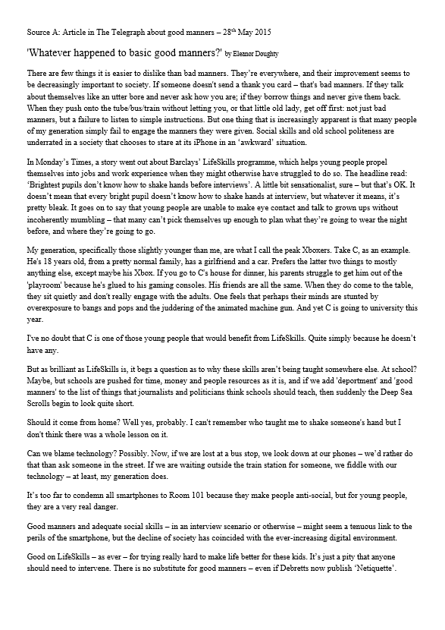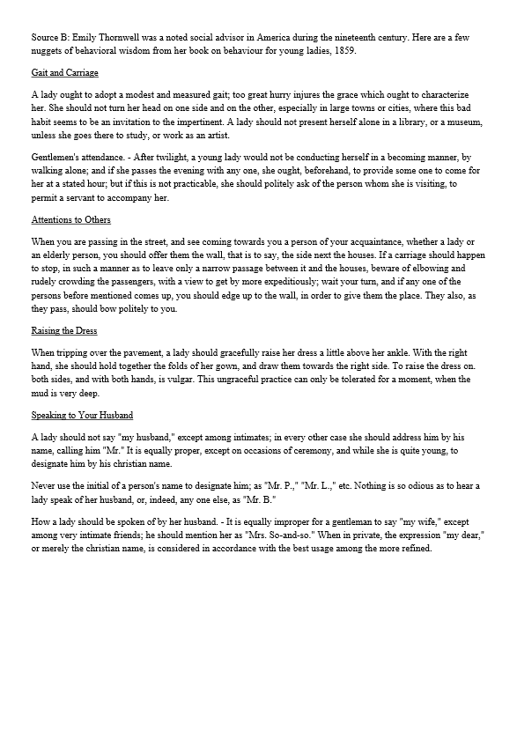
Source A and Source B, above are examples of the texts you could get in the exam for Language Paper 2 Section A: Reading. You need to read the questions first and then read the sources so you know what you are going to be writing about as you read and look for your evidence. You can highlight as you read.
The questions are broken down, below, with the answers for question 1.
You can use this as a practice paper.
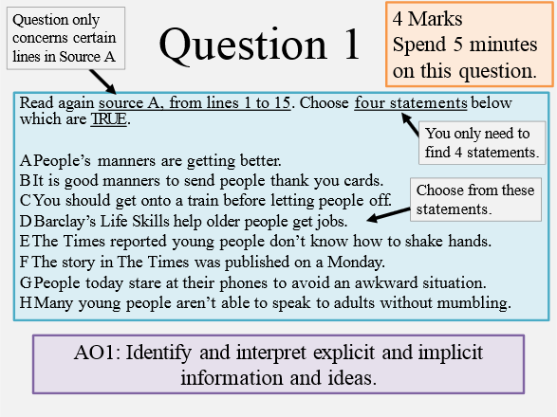
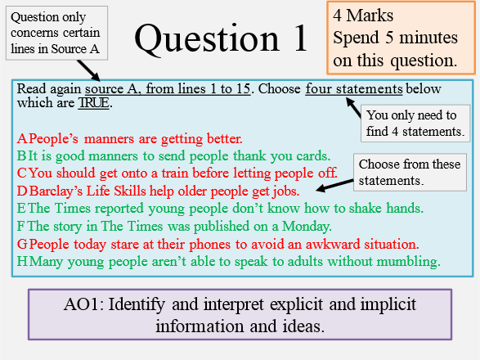
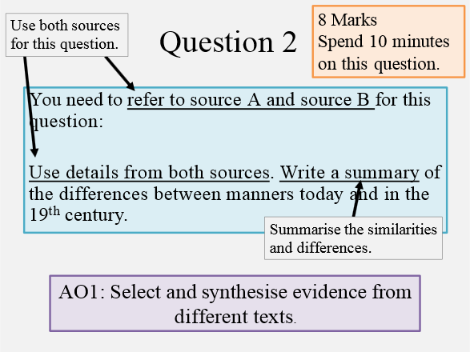
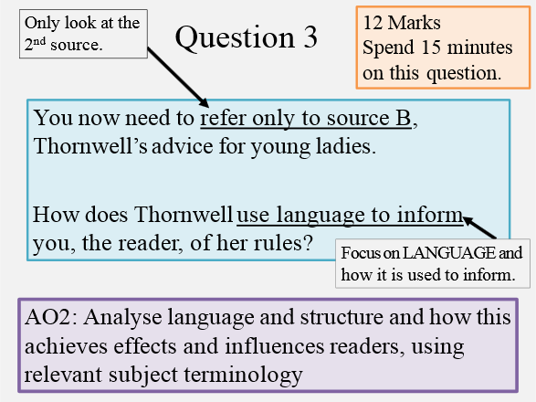
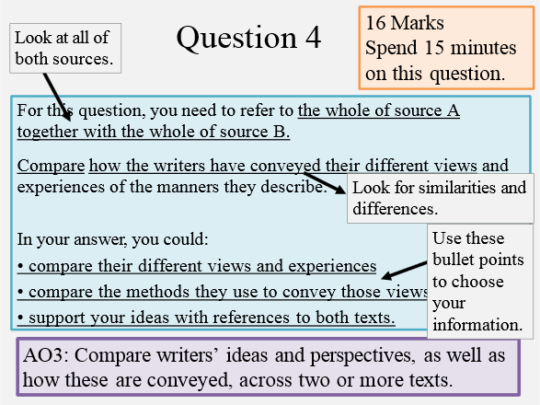
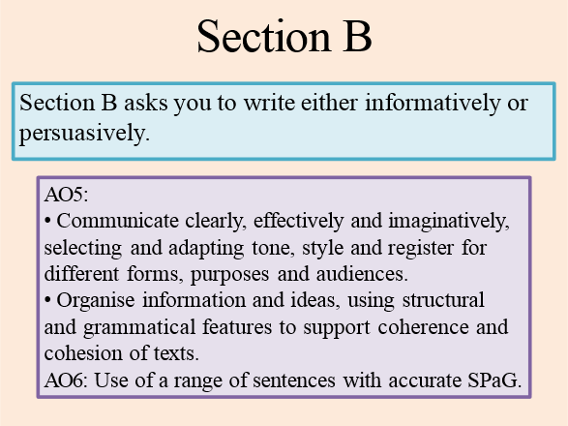
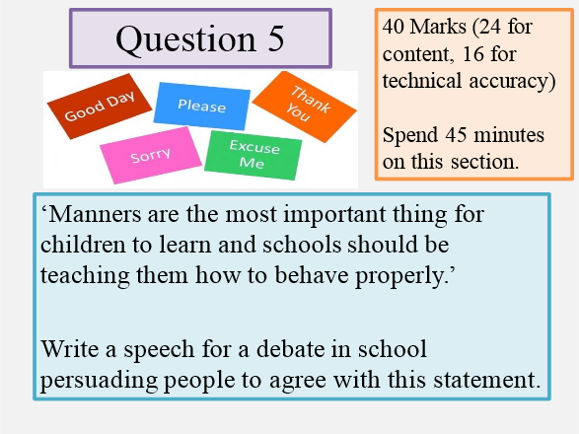

PRACTICE

GCSE English Language Sample AQA Paper
Paper Two

Writers’ viewpoints and perspectives
1 hour and 45 minutes

Section A - Reading Section B - Writing
Instructions
- Answer all questions
- You must answer the questions in the spaces provided
- You must not use a dictionary
Information
- The marks for questions are shown in brackets
- The maximum mark for this paper is 80
- There are 40 marks for Section A and 40 marks for Section B
- You are reminded of the need for good English and clear presentation in your answers
- Do all rough work on the paper. Cross through any work you do not want marked
- You will be assessed on your reading in Section A
- You will be assessed on the quality of your writing in Section B
Advice
- You are advised to spend about 15 minutes reading through the sources and all five questions you have to answer
- You should make sure that you leave sufficient time to check your answers.

Section A: Reading

Source A – you will need to download/print the pdf separately
The extract is taken an autobiographical work called the Narrative of the Life of Frederick Douglass, An American Slave, published in 1845 in Boston, America. It is taken from Chapter 10, Page 61.
Frederick Douglass was born into slavery but escaped and he became a powerful campaigner against slavery which led to the slaves being freed in America. In this extract he talks about his relationship with his slave master, Mr Covey, and his assistant, Mr Hughes, and what he learnt from this relationship.

Source B – you will need to download/print the pdf separately
The extract is taken from a speech in December 2013 by the US President, Barack Obama on the death of Nelson Mandela. It is a tribute to the life of Nelson Mandela, who rose from being a political prisoner in South Africa to being the first black president of South Africa. This is a shortened version of the original speech.
Mandela had fought against apartheid in South Africa. Apartheid was a policy adopted in South Africa in which black people were classified as inferior to white people and segregated from them.
For reference, the term Madiba used in the extract was a family name for Nelson Mandela.

Section A: Reading
Answer all questions in this section
You are advised to spend about 45 minutes on this section.
Question 1. Read again Source A from lines 1-16.
Choose four statements below which are TRUE. Put a tick alongside those that you think are true. Choose a maximum of four statements.
A. Frederick was glad to obey and go and feed the horses.
B. Mr Covey felt that he could do what he wanted with Frederick.
C. Frederick had decided beforehand to fight back against Mr Covey.
D. Mr Covey was expecting Frederick to fight back.
E. Mr Covey was frightened by Frederick.
F. Hughes was alongside Mr Covey in the stable throughout this incident.
G. Hughes attempted to tie both of Frederick’s hands.
H. Frederick fights back against both Mr Covey and Hughes. ( 4 Marks)
Question 2. You need to refer to Source A and Source B for this question.
Use details from both sources. Write a summary of the similarities between Frederick Douglass and Nelson Mandela. (8 marks)
Question 3. You now need to refer only to Source B, the speech by Barack Obama about Nelson Mandela.
How does Barack Obama use language in this speech to present his feelings about Nelson Mandela? (12 marks)
Question 4. For this question, you need to refer to the whole of Source A together with Source B.
Compare how the two writers convey their strong personal beliefs in these extracts and their beliefs in the importance of having freedom.
In your answer, you should:
- Compare the ideas about freedom and personal beliefs being conveyed
- Compare the methods the writers use to convey these beliefs
- Support your ideas with quotations from both texts. (16 marks)

Section B: Writing
You are advised to spend about 45 minutes on this section.
You are reminded of the need to plan your answer.
You should write in full sentences.
You should leave enough time to check your work at the end.
Question 5. ‘Violence is not the solution to conflict between people’.
Write a speech for your class in which you explain your point of view on this statement.
(24 marks for content and organisation- 16 marks for technical accuracy) (40 marks)

